

**Web-Based Interface Design**

**(CSF 3133)**

**LAB REPORT 2**

# NAME: WONG CAI YI

# MATRIC NO: S76084

# DATE: 29 October 2025

# GROUP: K4

# PROGRAMME: COMPUTER SCIENCE (SOFTWARE ENGINEERING)

2.3 Working with Tables

1. Basic table structure

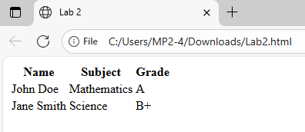

2. Attributes in table

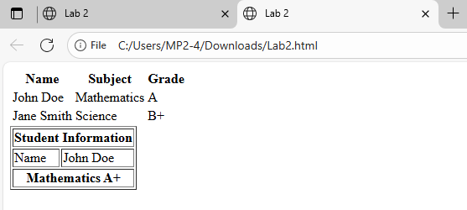

2.4 Creating Forms

2.4.1 Basic form elements

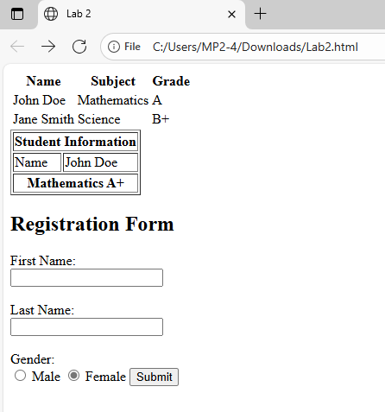

2.4.2 Other Form Element

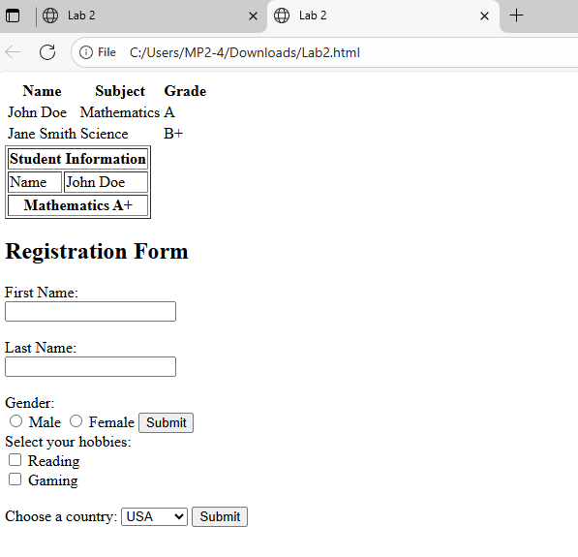

2.5 Semantic HTML

2.5.1 Common Semantic Tags

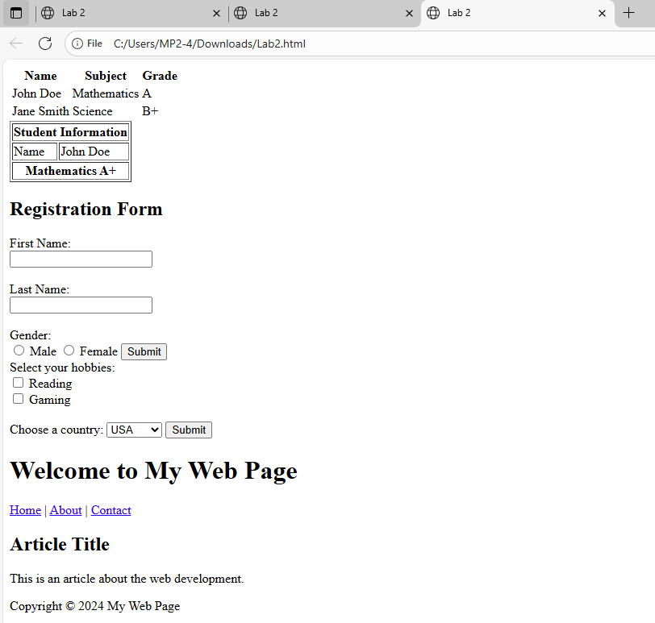

2.6 Lab Exercise 2

2.6.1 Building a Personal Profile Page

